2 men walk beside cart pulled by a yoke of oxen
2 men walk beside cart pulled by a yoke of oxen


Mule on the left and horse on the right, NPS image

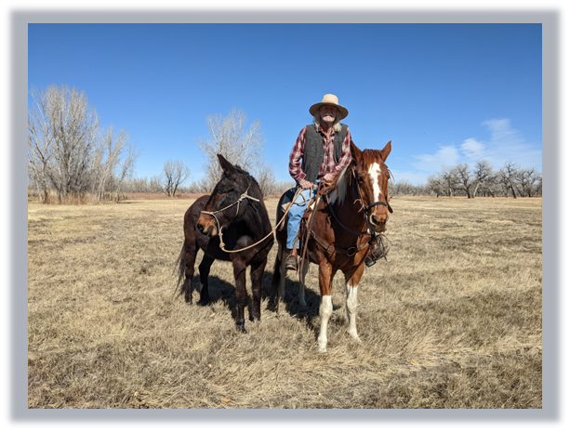

Bison herd, NPS image

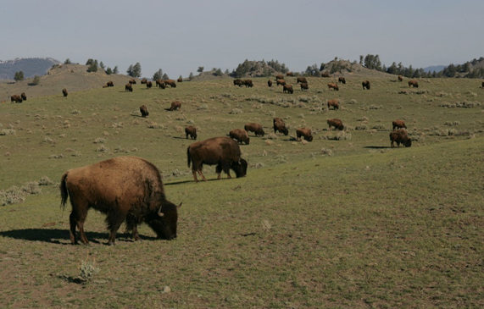

Prairie Rattlesnake, NPS image

Close-up of a coiled prairie rattlesnake on the ground


The Great Plains, photo by Marilyn Paul free (Accessed on Flickr 5-29-24)

Photo of the Great Plains under a blue sky
